|  |  |
| --- | --- |
| **February 15, 2023 Minutes of Monthly General Meeting**  Chair: Margo Murley Recorder: Elfi Berndl  Zoom Admin: Margo Murley | BurrHouse_BlackandGrey_Logo |

E&O

|  |  |  |  |  |
| --- | --- | --- | --- | --- |
| **In Attendance** Allison Durno Amanda Ring Athena Antiochos Doris Moneweg Eleanor Mayne Elfi Berndl Janet Porter Kara Kivioja Kathy Lakatos  Margo Murley Mary Davie Mary Dunn Michelle Zikovitz Peggy Spurgeon Saima Malik Sandra MacKenzie Sheila Hamilton Sophie Tepperman | | | **Regrets**  Adriana P.B. Amna Nawab Andre Beaumont Anthony Savanorato Barbara Anderson Christina Henninger Gail Gibson Julie Liut Leah Stone Linda Ewing Liz Kennedy Nancy Martin Olga Draznin Shiva Moghaddasi Susan Schillemore Teresa Clarke Val Firmin | **Honorary Members** Notification only  Joan Colnett  Jo-Ann Rootham  Kate Deuitch  Nancy Price |
| **Business - Agenda Items Information / Follow Up** | | | | |
| 1 | **Welcome & Members Update** | * New member Amna Nawab * Welcome new members Doris Moneweg & Sandra MacKenzie * Michelle has a new granddaughter, Saima has moved to be closer to family, Brampton, Amber is undergoing treatment | | |
| 2 | **Upcoming Classes / Guild Get Togethers** | * Krokbragd Weaving Workshop Feb 25 & 26 (10-12:30) w/ Kathy – FULL * Rigid Heddle Intro to Weaving - Mar 4 w/ Sheila * Thursday Afternoon Drop Ins (1:30) beginning in March * Wednesday Evening drop-in 7 pm – every week except for 3rd Wednesday * Tuesday Morning Weavers * Saturdays – if you want to start something up – consider doing something * 1st Saturday of month – Spinning in person or on Zoom – TBA monthly | | |
| 3 | **Upcoming Events to participate in** | * Mayor’s Maple Syrup Festival @ Richmond Green, April 1   + Michelle to put in application, Athena will help, tickle trunk, Margo come up with kid’s craft * Richmond Hill Cultural Summit, Wed. Apr. 26, 6-9pm   + Michelle to let them know, displays, Margo, Sheila, Elfi, Allison * Guild Spring Sale, May 6-7 * Richmond Hill Doors Open, Sat. May 13, 11am-5pm   + Gail & Kathy to head it up * Heritage Summit celebrating Richmond Hill’s 150th Sun. Sept 10   + Historical artifact Team – Elfi, Mary Davie, Allison | | |
| 4 | **Spring Guild Sale** | * let Sheila know if you plan to have items for sale * if you want to join Sales Team, let Sheila know * will decide after this Sale if we will continue to have 2 sales a year in 2024 * Shiva will take pictures end of Feb & March * need volunteers for before, during sale & after * after this sale, sellers can meet & decide if 25% is fair amount * Sari Tea Towel group weaving project – if you are interested in weaving a towel to donate to the sale, let Elfi know | | |
| 5 | **Website** | * Website Team – Michelle & Janet * website is still down, in the process to get access to website content and to determine why site crashed | | |
| 7 | **Executive Committee** | Position Vacancies 2023- 2025- for vote @AGM June 2023   * Secretary - outgoing Elfi Berndl 2021 – 2023 – looking for member willing to make a 2 year commitment to role and be member of Executive Committee, ask Elfi for details of job description if interested * Treasurer - outgoing Amber Bole 2019 - Dec 2022, Interim Elfi Berndl Jan – June 2023 – Elfi is willing to serve as Treasurer for 2023-2025 however if this is a role you would like and are willing to make a 2 year commitment & willing to be on the Executive Committee you are encouraged to discuss with Margo * Smaller tasks also exist such as teaching a craft class, offering a course open to members & the general public, doing a presentation at a general monthly meeting, head up one outreach event such as Maple Festival, Culture Days, Doors Open etc, maintain the equipment borrowing binder, oversee the floor loom booking, organize a Guild Hall cleaning event etc. For more ideas, talk with any member on the Executive Committee. The chances are they are doing a number of additional specific tasks that are not related to their role and would appreciate sharing the load. | | |
| 8 | **Craft Classes** | * Tassel Angels – 5 were donated for Guild Sales, materials for 10 more available for drop ins * Woven Reed Hearts - $195 donated to Guild * Programming – Kathy would like people to contact her if they have a course they would to teach or if there is a course they would like to take | | |
| 9 | **Community Outreach** | * Fidget Quilts – 7 have been donated to the Friends of Coombs * The Magic Yarn Project - 2 crocheters are in process of getting approved, Amanda is one of them. Opportunities for yarn cutting will be available soon | | |
| 10 | **Health & Safety** | * Covid Policy Update –as of March 1 the City of Richmond Hill does not have formal Covid policies * Have masks & hand sanitizers still available * keep tracking book * if you are not well, do not come * you can choose to wear a mask or not * an instructor can determine that all participants wear a mask as long as that is announced before people sign up | | |
| 11 | **Upcoming Presentations, Seminars** | * February to May Webinar series: Cotton **Ontario Handweavers & Spinners** * Sunday March 12, Hamilton Fibre Market, 10am-4pm * March 15 - Monthly Meeting Zoom - anyone? * April 18 - Monthly Meeting In Person - anyone * April 29i. Fleece Assessment Workshop Kimberly ON **Ontario Handweavers & Spinners** * May 17 - Monthly Meeting In Person - anyone? * June 2-4 Ontario Handspinning Seminar:, Burlington | | |
| 12 | **Opportunities** | * Michelle has some information for artists looking for opportunities in our community | | |
| 13 | **Meetings** | * April 18 & May 17 meetings in person & Michelle to book Burr House Tea Room * Anyone have a suggestion for a hands on activity we could do at the April 18 meeting? | | |
| **Presentation** | | | | |
|  | **Kathy Lakatos – A Look at Looms** Did you know there are different types of looms? Do you know if one is better, or preferable than another? Why are there different looms? How can I tell the difference between the various types? Join us on Wednesday, and Kathy will il**loom**inate us.  To see what floor looms our Guild has, see <https://docs.google.com/document/d/1BQQwOZrkc5G5xG3CPUAYyrEwsQwaWZNYTTPnPBcgjvE/edit>  To see what other looms and weaving equipment we have, look at our 2022 Inventory [https://docs.google.com/document/d/1PslES7d6uCCRa0\_Dnpr9uDFDEfG1jk\_IwUyYiBjdxd4/edit#](https://docs.google.com/document/d/1PslES7d6uCCRa0_Dnpr9uDFDEfG1jk_IwUyYiBjdxd4/edit) | | | |
| **Show & Share** | | | | |
|  | **Show & Share** | * Amanda – crochet - hexagon sweater, raglan sweater * Sheila – knit cotton sun hat, overshot pattern samples for cocktail napkins * Margo – homework – kerchief * Michelle – finished hemming core-spun yarn rug * Eleanor – sewing microwave mitts, dresses for the sale | | |

|  |
| --- |
| **Upcoming Events, Meeting Dates & Programs 2023:**   * **Sat & Sun Feb 25 & 26 Krokbragd Workshop w/ Kathy** * **Wed Mar 15 Monthly General Meeting 7 pm on ZOOM Program: Fiber, Yarn and Structure by Marcy Petrini** [**https://www.marcypetrini.com/**](https://www.marcypetrini.com/) * **Saturday April 1 10am – 2 pm Mayor West’s Maple Syrup Festival**    + @ Richmond Green Sports Centre * **Wed Apr 18, 2023 7 pm In Person @ Burr House, Tea Room, Program TBD** * **Wednesday April 26 6-9 pm ~ Richmond Hill Cultural Summit** ~ talk to Elfi if you will attend   + at Richmond Hill Centre for the Performing Arts, in evening * **May 6 & 7 ~ Spring 2023 Guild Sale** ~ ask Sheila how you can help * **Saturday May 13 ~ Doors Open ~ Open House at the Guild Hall** ~talk to Kathy & Gail if interested * **Wed May 17, 2023 7 pm In Person @ Burr House, Tea Room, Program: Spinning & All about Fibre by Margo Murley** * **Wed June 21, 2023 AGM Annual General Meeting In Person @ Elfi’s**   + Mix & Mingle 5 to 7 pm, Meeting 7 pm   + Annual Challenge Reveal "Fibre Ode to Our Favourite Thing" * **Sunday Sept 10, 2023 Heritage Summit @ Richmond Hill Centre for the Performing Arts**   + celebrating the 150th anniversary of the incorporation of the Village of Richmond Hill in 1873   + prepare a table & be present at the request of the Richmond Hill Historical Society |

|  |
| --- |
| **Roles & Responsibilities 2023**  **Executive Officers: President Margo Murley margo@murley.ca**  **Secretary Elfi Berndl elfiberndl@gmail.com Interim Treasurer Elfi Berndl elfiberndl@gmail.com**  **Membership Coordinator Peggy Spurgeon peggy@spurgeon.ca Guild emails BurrHouseW@gmail.com**  **Past President: Michelle Zikovitz mzikovitz@yahoo.ca**  **\*\*\*\*\*\*\*\*\*\*\*\*\*\*\*\*\*\*\*\*\*\*\*\*\*\*\*\*\*\*\*\*\*\*\*\*\*\*\*\*\*\*\*\*\*\*\*\*\*\*\*\*\*\*\*\*\*\*\*\*\*\*\*\*\*\*\*\*\*\*\*\*\*\*\*\*\*\*\*\*\*\*\*\*\*\*\*\*\*\*\*\*\*\*\*\*\*\*\*\*\*\*\*\*\*\*\*\*\*\*\*\*\*\*\***  **Conveners / Committee Chairs**  **Archives & History:**  **Burr House Building Booking Coordinator: Michelle Zikovitz mzikovitz@yahoo.ca**  **FaceBook: Elfi Berndl**  **Guild Sales: Sheila Hamilton**  **Librarian: Olga Draznin**  **Monthly Meeting Programming : Vacant**  **ONCA Project Team (to 2024): Elfi Berndl**  **Sheep to Shawl 2023: Vacant**  **Social / Housekeeping: Vacant**  **Spinning Chair: Margo Murley**  **Studio Head: Vacant**  **• Looms & Equipment: Vacant**  **• Inventory: Vacant**  **Weaving Chair: Vacant**  **Website Team: Janet Porter Michelle Zikovitz**  **Workshop Coordinator: Kathy Lakatos**  **\*\*\*\*\*\*\*\*\*\*\*\*\*\*\*\*\*\*\*\*\*\*\*\*\*\*\*\*\*\*\*\*\*\*\*\*\*\*\*\*\*\*\*\*\*\*\*\*\*\*\*\*\*\*\*\*\*\*\*\*\*\*\*\*\*\*\*\*\*\*\*\*\*\*\*\*\*\*\*\*\*\*\*\*\*\*\*\*\*\*\*\*\*\*\*\*\*\*\*\*\*\*\*\*\*\*\*\*\*\*\*\*\*\***  **Study Groups / Interest Groups**  **Tuesday Weavers Drop In**  **Wednesday Night Drop In**  **Thursday Afternoon Drop In: Margo Murley**  **Saturday Spinners: Margo Murley**  **\*\*\*\*\*\*\*\*\*\*\*\*\*\*\*\*\*\*\*\*\*\*\*\*\*\*\*\*\*\*\*\*\*\*\*\*\*\*\*\*\*\*\*\*\*\*\*\*\*\*\*\*\*\*\*\*\*\*\*\*\*\*\*\*\*\*\*\*\*\*\*\*\*\*\*\*\*\*\*\*\*\*\*\*\*\*\*\*\*\*\*\*\*\*\*\*\*\*\*\*\*\*\*\*\*\*\*\*\*\*\*\*\*\***  **Liason**  **Joint Burr House Use Committee: Margo Murley, Michelle Zikovitz, Shiva Moghaddasi**  **City of Richmond Hill: Michelle Zikovitz**  **Richmond Hill Arts Council: , Richmond Hill Historical Society,**  **Ontario Handweavers & Spinners – Shiva Moghaddasi**  **\*\*\*\*\*\*\*\*\*\*\*\*\*\*\*\*\*\*\*\*\*\*\*\*\*\*\*\*\*\*\*\*\*\*\*\*\*\*\*\*\*\*\*\*\*\*\*\*\*\*\*\*\*\*\*\*\*\*\*\*\*\*\*\*\*\*\*\*\*\*\*\*\*\*\*\*\*\*\*\*\*\*\*\*\*\*\*\*\*\*\*\*\*\*\*\*\*\*\*\*\*\*\*\*\*\*\*\*\*\*\*\*\*\***  **Website Under Construction**  **FaceBook https://www.facebook.com/BurrHouseSpinnersWeavers**  **email to all Guild Members Burr House Fiber Arts – All Members burrhouse@googlegoups.com**  **etransfer of funds to Burr House Spinners & Weavers Guild BurrHouseW@gmail.com**  **Membership enquiries, general correspondence** **BurrHouseW@gmail.com** |

*Take a look at May!:-) This 2023 Calendar is from Majid Jowhari, Member of Parliament, Richmond Hill.*

**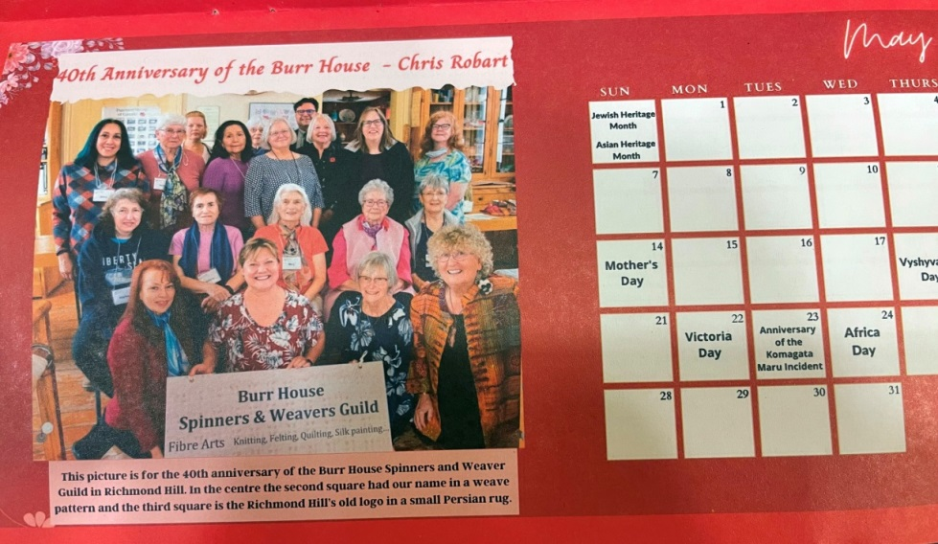**

***Craft Classes January & February ...***

|  |  |
| --- | --- |
| ***C:\Users\GMB\Documents\BHSWGuild Files Elfi Jan 17  2023\Classes Workshops Activities by Guild\Tassel Angels\2023 Tassel Angel.jpg***  **C:\Users\GMB\Documents\BHSWGuild Files Elfi Jan 17  2023\Classes Workshops Activities by Guild\Tassel Angels\Tassel Angels.jpg** | ***C:\Users\GMB\Documents\BHSWGuild Files Elfi Jan 17  2023\Classes Workshops Activities by Guild\Woven Reed Hearts\2023 Woven Heart class b.jpg***  ***C:\Users\GMB\Documents\BHSWGuild Files Elfi Jan 17  2023\Classes Workshops Activities by Guild\Woven Reed Hearts\2023 Woven Heart class.jpg*** |