March 16, 2022 Minutes of Monthly Meeting  Chair: Margo Recorder: Elfi  https://us04web.zoom.us/j/9027180459 Zoom Admin: Amber | 

In Attendance 22  Amanda R. Amber B. Athena A. Deborah O’S. Eleanor M. Elfi B. Gail G. Janet P. Kara K. Kathleen R. Kathy L. Liz K. Margo M. Mary Da. Mary Du. Megan M.C. Olga D. Peggy S. Saima M. Sheila H. Shiva M. Sophie T. Susan S. |  |  | Regrets  Allison D. Anthony S. Barbara A. Christina H. Helen O’S. Julie L. Linda E. Michelle Z. Nancy M. Teresa C. Val F. | Notification only  Joan C.  Jo-Ann R.  Kate D. Nancy P.
 | Business Portion of Meeting 7:00 pm
 | Agenda Item | Information / Decision / Further Action by
1 | Welcome
2 | 40th Anniversary Guild Hall Celebration October 2022 | October 2022 will be our Guild Hall’s 40th Anniversary  (see From the Guild Hall Archives ...at end of minutes)  - can celebrated during Culture Days (September 23 – Oct 16, 2022)  - in conjunction with Sheep to Shawl  - involve Potters, invite former members, honour long time members  Action: if interested in being on the 40th Anniversary Committee, email Margo
3 | Vacant  Volunteer Positions | Background: We need volunteers to take up these roles for 1 or 2 years  Cleaning Co-ordinator – email Elfi for details  Monthly Meeting Programming Coordinator (s) – email Megan & Amanda for details  Action: email Margo or Elfi if you would like to put your name forward
4 | ONCA - Charitable Corporations - compliance | Our Guild needs to comply with the ONCA Act by our AGM Sept 2023  - Burr House Spinners and Weavers Guild (1143567) is a Not-for-Profit Corporation incorporated on October 12, 1995  Information: if you want to learn more about the requirements  - Charitable Corporations - compliance https://www.ontario.ca/page/rules-not-profit-and-charitable-corporations  - Ontario Nonprofit Network https://theonn.ca/our-work/our-regulatory-environment/onca/  - perhaps assistance available from OHS, information from other clubs members know of who have already complied  Action: members interested in being on the ONCA Working Committee,  email Margo
5 | Spring Guild Sale  April 30 - May 1, 2022 | Information: Thing are progressing well - Kathleen  - Sheila will work on writing up Quality Standards in fibre areas using input from those members who have expertise  - small business size cards will be printed up  - donations for the sale are in progress: Felted Soaps (20), Snow Dyed Silk Scarves (6)
6 | June Meeting | Our Wed June 15th 2022 Monthly Meeting will be an in person social meeting. Specific details to be determined shortly.  - the meeting will take place in the parking lot, The Guild Hall and the Burr House Tea Room  Action: Tea Room to be booked. Potters to be informed by Margo.
7 | Gardening | - The Potters have decided to move forward with establishing a Pollinator / Community Garden under the leadership of Lucy Di Pietro lucy.dipietro@yahoo.ca  - no Weaver so far has expressed interest but if there is interest they should contact Lucy directly  Information: Elfi, on behalf of The Dye Group, is considering establishing a Local Natural Dye Plant Registry – for use by Guild Members.
8 | Joint Project with Potters | - Weavers would like to have more occasions to connect with Potters  - The Empty Bowl collaboration would be a fundraising event for local charities. This was mentioned by Katie 2 years ago.  - An event like Fibre & Fire would be a collaborative Art Show like the one held in 2017.  Action: If any member is interested in spearheading either type of endeavor, that would be wonderful. Until interest is expressed, these projects are still in the idea phase.
Program: 7:30 pm Introduced by Programming Co-Coordinator - Megan
Presenter: Sally Shearman, owner of Sharon Creek Farm, Sharon ON
Sally is a permaculture farmer with a small certified organic farm in East Gwillimbury. The main outputs of the farm are fruit, garlic, eggs, wool and wool products. Sally has a diverse background and an eclectic resume, including a degree in French and German, a Design Arts diploma in Pottery, an Education degree, and a certificate in Landscape Design. She has worked as a studio potter, an art instructor, a visual arts teacher, a dyslexia specialist, a landscape designer and an organic farmer. She maintains a flock of Babydoll sheep and Shetland sheep, who are gainfully employed in groundskeeping in the orchards and who donate their gorgeous wool every spring to Sally's spinning and felting stash.
Bricks & Mortar Store Online Store website sharoncreekfarm.ca https://www.sharoncreekfarm.ca/
FB https://www.facebook.com/sharoncreekfarm/

Show & Share: 9 pm
- Sheila – baby blanket )(Monte Cristo yarn – boucle), snow dyed silk scarves
- Amanda – crochet bag
- Kathy – fabric drawstring bag, lacy woven scarf from cotton boucle, woven placemats
- Elfi – bread basket cover , basket, felting needle pin cushion in a pot
- Kara – triangle shawl, snow dyed silk scarves
- Amber - flock of knitted sheep
- Mary Davie – 4 shades of dyed marigold yarn, will be trying daffodil heads this year
- Kathleen – collaboration with indigenous artist – tryptic – quilt – painting on fabric & stitched – 3 panels on display June 12th in Coldwater at grand opening at the Mill https://coldwatermill.com/

- 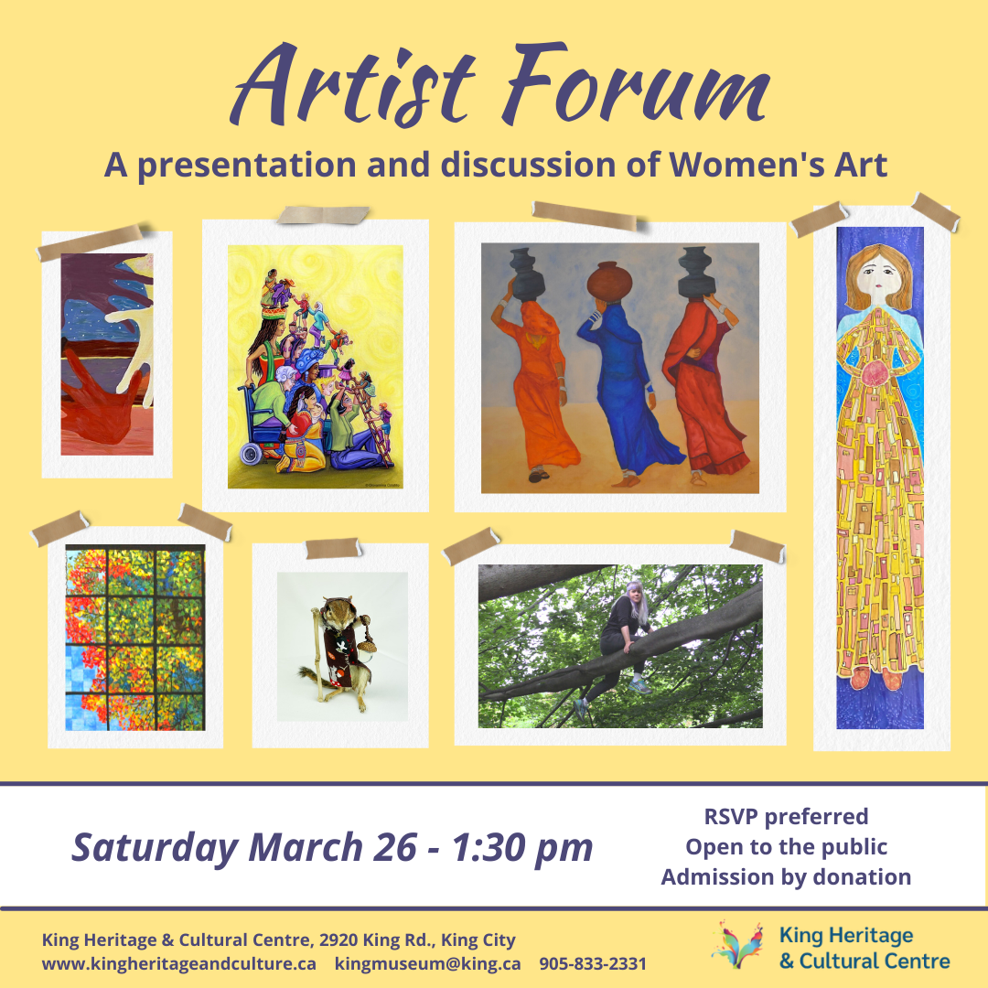

- Artist forum – Shiva & Kathleen participating

Upcoming Events, Meeting Dates & Programs:
- Tuesday March 22, 2022 10:30 to noon; Make Felted Soaps with Val
- Sunday Mar 27, 2022 CLASS: Make a Penannular Brooch with Liz Kennedy
- Saturday April 9, 2022 10:30 to noon; Make Felted Soaps with Val
- Tuesday April 12, 2022 7 pm Executive Council Meeting via Zoom
- Wed Apr 20 2022 7:00 pm Monthly Meeting via Zoom,
Program@ 7:30 Presenter: Megan Samms, owner of Live Textile in Newfoundland
Megan Samms is a weaver, regenerative farmer and natural dyer in Katalisk Sipu (Cordroy Valley, Newfoundland). She is also the current Vice President of the Guild of Canadian Weavers. Through her business Live Textiles, Megan produces handwoven cloth as well as weaving and knitting drafts. Her expertise and commitment to raising the technical bar for handweaving in Canada has made her a juried member of the Newfoundland Craft Council and a provincial representative in the Guild of Canadian Weavers. Megan will speak to us about natural dying, her contemporary weaving and her life living off the grid in Newfoundland.
- Wed May 18 2022 7:00 pm Monthly Meeting via Zoom, Program@ 7:30 TBD
- Wed June 15 2022 6:30 pm Monthly Meeting ~ Social In Person Get Together at the Burr House Tea Room, Guild Hall and Parking Lot
- Wed September 21, 2022 7 pm AGM Annual General Meeting via Zoom

Roles & Responsibilities Mar 16, 2022
Executive Council: President Margo Murley margo@murley.ca
Co-Pres Athena Antiochos athena1887@gmail.com
Treasurer Amber Bole aabole@gmail.com Secretary Elfi Berndl elfiberndl@gmail.com
Membership Peggy Spurgeon peggy@spurgeon.ca BurrHouseW@gmail.com
Past President: Michelle Zikovitz mzikovitz@yahoo.ca
*******************************************************************************************************************
Conveners / Committees: Contacts & Coordinators
Cleaning Coordinator: Vacant
Covid Committee: Michelle Zikovitz mzikovitz@yahoo.ca
Librarian: Olga Draznin odraznin@gmail.com
Looms & Equipment: Susan Schilemore susans@null.net
Programming: Vacant
Sales: Kathleen Rodgers kathleen.rodgers@sympatico.ca
Workshops Kathy Lakatos kathy.lakatos@gmail.com
Web Team Janet Porter synaptiqa@gmail.com Shiva Moghaddasi info@shivaGallery.com
Web http://www.burrhousefiberarts.com/
FaceBook https://www.facebook.com/BurrHouseSpinnersWeavers
email to all Guild Members Burr House Fiber Arts – All Members burrhouse@googlegoups.com
etransfer of funds to Burr House Spinners & Weavers Guild BurrHouseW@gmail.com
******************************************************************************************************************
Study Groups / Interest Groups
Dye Group: Elfi Berndl elfiberndl@gmail.com
Saturday Spinners: Margo Murley margo@murley.ca
New Weaver Study Group: Megan Crouse mcrouse@kiosq.ca
******************************************************************************************************************
Liason
Burr House Building Committee: Michelle Zikovitz mzikovitz@yahoo.ca
City of Richmond Hill: Michelle Zikovitz mzikovitz@yahoo.ca

From the Guild Hall Archives ...
20th Anniversary of the Official Opening of “The Guild Hall” Sunday October 6, 2002
Source: Photo Album

